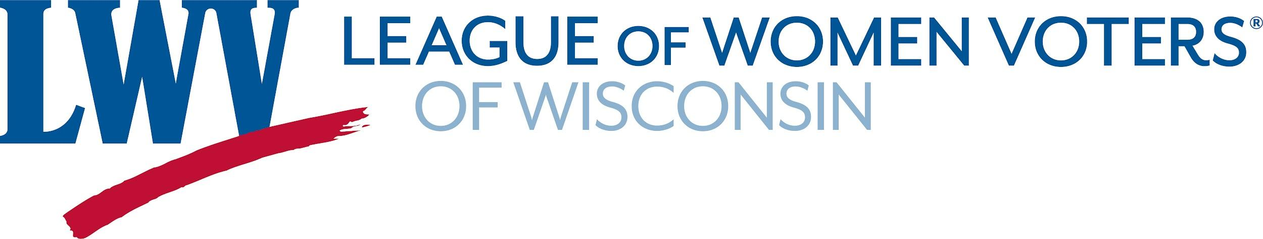
LWVUS Evaluation Training Series
Session #2
Thursday, May 12, 7PM EST

What? So What? Now What?: LWVWI DEI Survey, Year Two
Maria Douglas, MS, LWVWI Senior Diversity Equity and Inclusion Specialist

Good evening! My name is Maria Douglas, the League of Women Voters Wisconsin, Senior Diversity, Equity and Inclusion Specialist. I am here to share the What, So What, and Now What of our DEI survey process and data application to give you ideas of where to start or continue in your state’s DEI transformation.

Slide 2
Our ability to tell our individual and collective League stories hinges on state and local Leagues collecting and reporting data.
-Amilcar Guzmán, Ph.D., Director of Outcomes and Evaluation for the LWVUS

Slide 3
The idea of creating a Diversity, Equity and Inclusion (DEI) survey originated within our statewide Community Alliances Committee (CAC). The CAC is a mutually supportive learning group composed of members from 13 of our 20 local Leagues, that share information and strategies to strengthen and expand our Leagues’ diversity as stated in our DEI Policy.

Slide 4

WHAT?
*****

First we are going to talk about Survey design and goals

The three annual DEI surveys (2019-2021) we’ve administered to date were designed by members of the CAC committee to track the progress of local Leagues as they continue to plan, implement and review their work through the lens of DEI. None of these members were professional demographers, and surveys were sent out in google forms.

We hoped to learn 4 things through these surveys:
- What progress is being made regarding the DEI initiative
- What is the impact of the support from the LWVWI and the CAC
- What more do local leagues need from us to continue with their plans to transform viewing their work through a DEI lens
- What is the impact of Board support and resources?

Also, the annual use of the survey is designed to monitor the forward movement of Leagues’ implementation of DEI over time. We’ve made changes along the way and continue to evaluate our questions and distribution methods.

Our first survey was distributed in late 2019. The baseline data from that survey was useful in identifying resources and guidance needed to help local Leagues further their DEI work. 2019 Results informed our assessment of 2020 survey results by providing benchmark data for comparative analysis.
The 2020 DEI Survey included some, but not all, of the same questions asked in 2019 and that will be true of all surveys going forward. As new initiatives and resources are introduced, it’s important to create new questions to measure their impact and usefulness. It was also our intent to collect qualitative as well as quantitative data. Leagues’ subjective responses to open-ended survey questions were shared with all Leagues to facilitate an understanding of where they fall on the spectrum of progress and pacing in their decentralization of DEI. Learning from each other along the way is equally vital to our efforts as any formal DEI training. It’s important to communicate that we are on the DEI journey together and there is no right or wrong pace at which to move or place to start.

Slide 5

Survey design tips

Keep it concise!

It’s important to keep in mind that the longer your survey is, the more likely respondents will become lackadaisical with their answers or not complete the survey. Try to capture data as efficiently as possible.

Question design
After identifying the purpose and goals of a survey, the next step is question construction. Question types fall into two broad categories:
- Measurable or quantitative questions
- Open-ended or qualitative questions

A “measurable” or “quantitative” question offers a constricted range of options to choose from as answers. It is known as “quantitative” because the response options can be converted to numbers. Using quantitative questions makes questions clearer, data quality better, and analysis quicker and easier.
An “open-ended” or “qualitative” question is one where the respondent is free to answer in any manner of choice. No response options are given, and responses are interpreted and measured by feel rather than by mathematics.

Slide 6

SO WHAT?

Using Measurable and Quantitative questions
Our understanding of how DEI can be systematically decentralized within League guided the development of several measurable, or quantitative, survey questions. We felt that when a local league adopted and publicly displayed the DEI policy as well as have a DEI point person or committee tasked with ensuring that all operations are viewed through a DEI lens, then when we are on the same page. From here, Local Leagues are encouraged to develop their own DEI strategies and action plans unique to the communities they represent and serve.

The following are the measurable questions regarding basic DEI implementation:

- Has your League adopted a DEI Policy? That’s a measurable first step. We were able to drop this question in the 2021 survey as all leagues had answered this affirmatively.
- Is your DEI Policy posted on your website? Making this policy known through public sharing deepens its intent. Not only will we evaluate our work by our DEI Policy standards but others outside our organization will also.
- Have you added the LWVUS DEI Policy bylaws language, approved at the 2020 LWVUS Convention, to your bylaws? This is affirmation of how DEI is now a core institutional value on par with the League’s nonpartisanship policy and when core values are aligned within an organization through the uniform adoption of policies and intent, decision-making and activity in pursuit of the shared values is more readily decentralized.
- Does your League have a DEI Committee or a designated position tasked with ensuring that your League’s work is viewed through a DEI lens? This data point is indicative of local Leagues’ deepening commitment to DEI.

Using Subjective/Qualitative Questions
Heightened awareness and acceptance of the need for a DEI Policy within the League can be quite different from understanding what DEI actually means. To capture where each league is on this journey, we asked subjective questions to gauge emotion and intent and allow for as much or little sharing of ideas. These answers provided tremendous insight into each League’s engagement with and “buy-in” to DEI. Here is an example of why subjective questions are so important. Let’s take the question, Has your understanding of DEI as applied to how you view your League’s work through a DEI lens improved over the past year?

The 2019 DEI Survey asked a similar but not identical question, In a couple sentences, what does DEI mean to your local League? Based on responses in 2019, the majority of Leagues highlighted their partnerships, relationships, collaborations, and the networking they do with diverse organizations as almost their sole indicator of what DEI implies. As partnerships grow more consistent, trusted and reciprocal, DEI is further decentralized and internalized. A year out from the first survey, most Leagues seem to have shifted toward a broader understanding of DEI in the sense that it’s not being seen solely in the context of external partnerships but also as internal work which includes self-reflection of unconscious bias and an honest examination of the legacy of white privilege in League.

Slide 7
Open-ended questions are useful in identifying specific needs while noting overlap between leagues. They may also be used to assess if leagues are aware of existing policies and resources in a non-confrontational way. The survey asked, What would your local League like to learn more about regarding diversity, equity and inclusion? In what ways can LWVWI support you in this? Answers fell into both internal and external categories.
Answers to this narrative question provided the CAC with much of the information that was used to create the goals and tasks chosen to move forward.

For internal DEI growth and development, Leagues relayed these requests as shown on this slide:

*DON’T READ*

- want to know what other local Leagues are doing.
- asked for training that would help members understand unconscious bias and what it means to be racist, without feeling defensive.
- requested strategies or guidelines in how to educate local leaders and members about implementing DEI principles within their Leagues.
- identified the need to have a DEI point person in the state office.
- asked for a list of recommended speakers, films, movies, webinars, workshops, etc., on DEI that they can readily reference in program planning.
For external DEI growth, the overwhelming need expressed was for training opportunities on membership and voter service outreach to minority communities and marginalized groups. Specifically mentioned was a desire to connect and engage effectively with and build coalitions with high school and post-secondary students, non-students age 18-30, the LGBTQ+ community, local Native American Tribes throughout the state, and people of color in general.

Slide 8
If funding were available from the state, local Leagues would use it in the ways as shown on this slide:
*DON’T READ*
- DEI speakers and training opportunities on DEI literacy for their local leadership and/or membership
- training on outreach strategies to the diverse groups mentioned above
- the purchase of books/videos, etc. for member discussion, interpretation services for candidate forums and other types of public programming
- translation services for publications
- printing costs for multi-language voter service materials
- tech support training
- membership fees to join other organizations and participate in other organizations' events
- co-sponsoring speakers and workshops with other community based organizations.

Slide 9

NOW WHAT?
Drawing the broadest conclusions from what we’ve learned help us make meaningful decisions going forward.

Slide 10

Key findings from the 2020 DEI survey are:
● Further movement of decentralization of DEI in League.
● Work on improving how we measure DEI progress, making the survey less redundant and targeted to more essential fact finding.
● Provide training workshops to build competencies that align with DEI values.
● Create a template for communicating and addressing instances of bias.
● Improve League to League communication around DEI efforts so Leagues may benefit from what others are doing.
● Maintain LWVWI Board approved waiver of Per Member Assessment (PMA) payments for members who join Leagues under a reduced fee membership option. Survey results indicated that this increased membership and diversity in membership.
● Skill building for establishing trusting relationships with outside organizations.

Slide 11

Based on the 2020 survey results:

The LWVWI hired a Senior DEI Specialist- me! My role is to facilitate the development of DEI positions/committees in each league across the state, provide regular training and mentoring opportunities to membership, to create goals and measure progress re: the decentralization of DEI across the state, to aid local leagues in increasing membership that reflects the demographics of their particular league, and lastly to examine that all areas of functioning in and materials utilized by the LWVWI are being viewed through a DEI lens while supporting local leagues in the same effort.

The CAC has identified goals and have organized work groups to focus on each of these goals:

- To deepen our Ability to Establish Trusting Relationships with our Colleagues and partners as we become a more diversified league by listening well and decentralizing DEI.
- To provide peer learning opportunities for league members of our historically white dominated organization and leadership for increased self-awareness and change.
- Focusing on structural age bias in the LWVUS bylaws.
- Create a pathway document to outline how local leagues can address incidences of bias.

Slide 12

The CAC also created the following framework and initial process of how local leagues can incorporate DEI into all areas of work at the local league.
So DEI is found throughout the local LWV structure
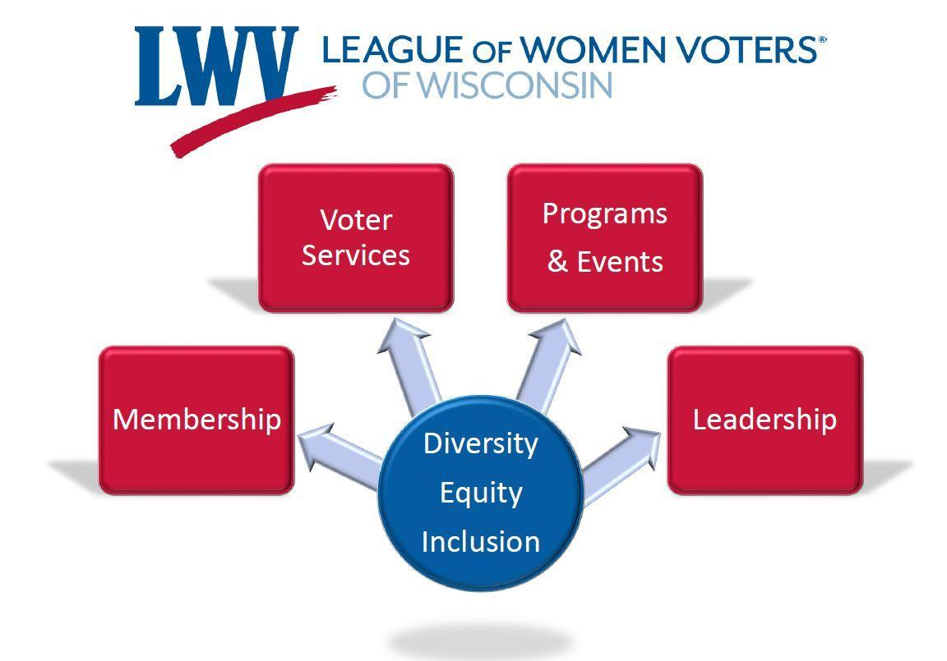
The LWV-WI Board and staff, along with the CAC, will support local Leagues as each implements DEI at the local level. This process includes:
1. Exploring the meaning, impact, value, need, and urgency of DEI
2. Agreeing on the end goal of DEI at the local level and recognizing it as an ongoing commitment
3. Creating measurable strategies and steps towards this goal and communicating it to the broader community
4. Sharing successes, challenges and ways to improve strategies through mutual support among leagues
Initial Steps
● Local Board leadership and members initiate discussions that use this image and the following menu of questions that help build a common understanding of DEI.
● Select one topic at a time within small groups, then each small group reports out.
● Invite groups to prioritize the questions, choose to discuss work already being undertaken, and/or which may require further study, education, or development for implementation.
● Document key discussion points, questions, needed support and implementation strategies.

As you can see this document includes a sampling of questions for board leadership, membership, policy issues, programs & events, and voter services & other programming. The CAC created a long version of this document which incorporates an exhaustive list for each category. This framework guides the process of setting up a DEI committee and initial questions to begin decentralizing DEI.

As a final note- We need to realize that we are all in this together. Many are early in their journey and it will be a lifelong journey. We must remind ourselves and others that there is always support. In WI there is the CAC and LWVWI staff Ellen Penwell and myself. Nationwide, each state has their respective state league, national league, and fellow interstate leagues. Thanks, LWV US for this gracious opportunity to present this evening.

Slide 13
-END-

